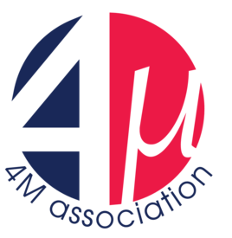
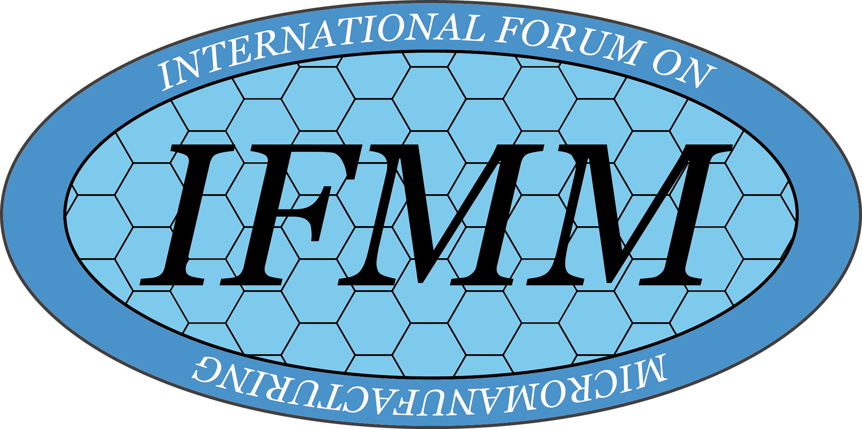
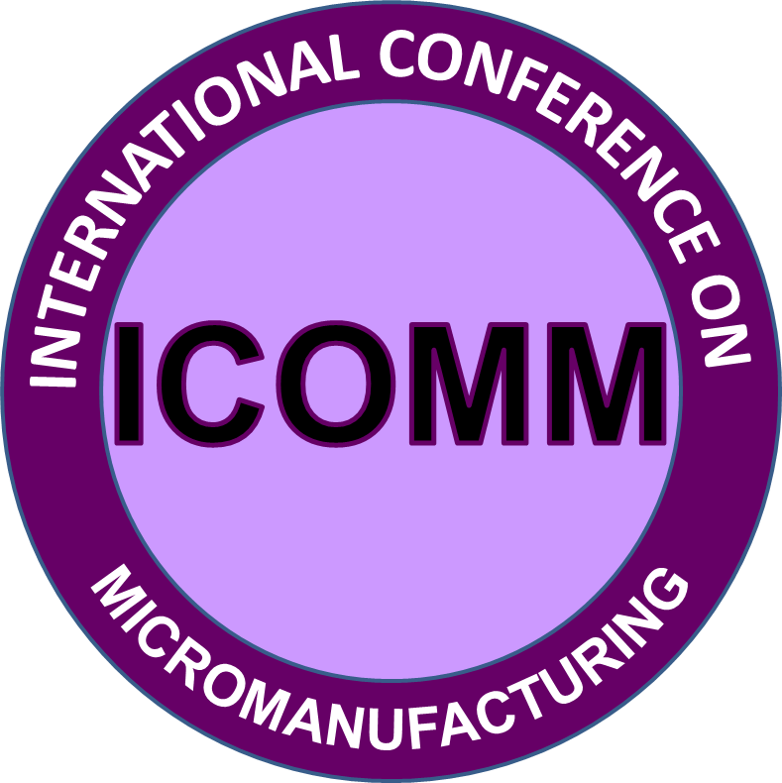



WCMNM 2022
5th World Congress on Micro and Nano Manufacturing
Jointly organised by the 4M Association, the International Institution for Micro Manufacturing (I2M2) and the International Forum on Micro Manufacturing (IFMM)

Conference Chair: Sylvie Castagne, KU Leuven, Belgium

Conference Co-Chair: Stefan Dimov, University of Birmingham, UK (4M)
Lawrence Kulinsky, University of California, Irvine, USA (I2M2)
Kuniaki Dohda, Northwestern University, USA (IFMM)
Dominiek Reynaerts, KU Leuven, Belgium



19th-22nd September 2022
Leuven, Belgium

Co-Organised by KU Leuven, 4M Association, IFMM, I2M2 and University of Birmingham

http://www.4m-association.org/conference/2022

Themes
Papers are invited that present original research and development in processes and process chains for multi-material micro and nano manufacture, in particular but not limited to:

- Micro fabrication technologies, process chains and process characterisation
- Novel product designs, micro-assembly technologies and micro-handling
- Surface engineering and interface nanotechnology
- Process modelling and simulation
- Processing and characterisation of smart materials, multifunctional materials, nanomaterials and material related issues in micro and nano scale
- Micro and nano additive manufacturing technologies
- Micro and desktop factory concepts, systems, components and modules
- On-line monitoring and inspection systems/methods
- Standardization in micro manufacturing and micro factories
- Applications of micro and nano technologies: microreactor technologies, microsensors and actuators

These topics represent the intended content of the WCMNM 2022 thematic sessions, to which the authors are invited to submit papers.

Submission of Full Papers
- Submission site opens: 15th of January 2022 Deadline: 30th of April 2022

Paper Review
To ensure a high-quality Conference all papers will be reviewed by the congress’ Scientific Committee under the leadership of the Scientific Chairs.
Oral and Poster presentation
Submitted papers may be selected for oral or poster presentation. All oral and poster presentations will be included in the Conference Proceedings.
Important Dates:
- Submission site will open:
- Submission deadline for full papers: 30th of April 2022
- Feedback from the peer review to authors: 4th of June 2022
- Submission deadline of revised final paper: 18th of June 2022
- Notification of acceptance in Final Publication:
- Authors Final Registration:
- Public Final Registration:

Proceedings:
All final papers accepted for presentation may be included in the WCMNM 2022 Proceedings to be published by Research Publishing Services. Selected papers may be considered for publication in Special Issues of Micromachines and Journal of Micro and Nano Manufacturing.
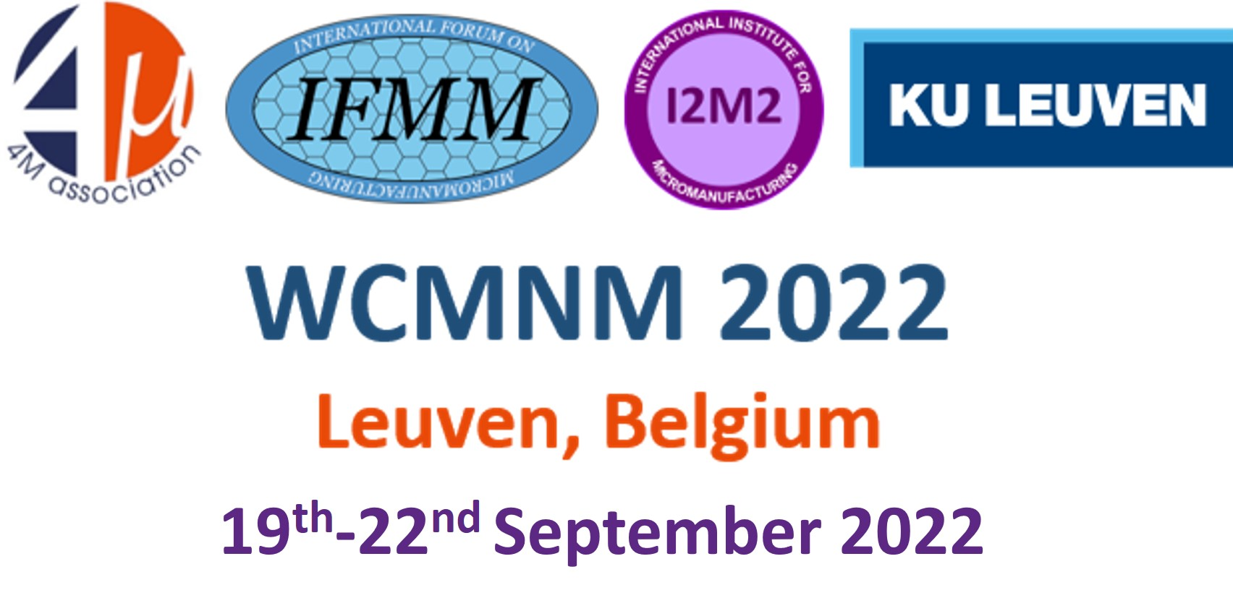
4M Association Officer
Adriana Svetozarova
University of Birmingham, Edgbaston, Birmingham B15 2TT, UK
E-mail: a.svetozarova@bham.ac.uk

